**The Gentrification of Berlin seen through the lens of Vegan/Vegetarian restaurants.**

What can the frequency of Vegan/Vegetarian restaurants tell about the demographics of Berlin's neighbourhoods?

Rob Clem

06/07/2021

**Introduction**

**Background**

Berlin is a city that has seen vast changes since the fall of the berlin wall and the end of the cold war. On such changes is a perceived gentrification of part of the city which have gained a reputation for being a more bohemian, young and "hipster". Another widely held perception is that within this demographic of young and "hipster" type people is that veganism and alternative diets are popular. This project aims to test these assumptions and gather the most vegan friendly areas of Berlin using available data.

**Problem**

The problem may sound trivial; however, it is hugely important to understand the demographics of cities in order to understand its people, needs and problems. This is especially true in Berlin that has seen vast changes since the reunification of Germany in the early 1990s which created much change in berlin including an influx of new arrivals or the re-settlement of people into the urban centres which in turn has led to the displacement of others due to inflating rent prices. Such phenomena have been phrased as gentrification (1) and has put pressures on local government who try to balance urban renewal whilst limiting the negative effects (2).

1) Zerofsky (2019) - <https://www.newyorker.com/news/dispatch/the-causes-and-consequences-of-berlins-rapid-gentrification>

2) Levine (2004) - <http://rohcavamaintenant.free.fr/USB%20KEY%20Fahriye/GENTRIFICATION/Government%20Policy-The%20Local%20State-and%20Gentrification.pdf>

**Interest**

The results of the research could provide helpful for government, town planners, businesses and residents as a guide to more traditional areas with more gentrified and younger areas of the city.

Berlin has 12 boroughs (berzirke) all of which are split into a number of further ne

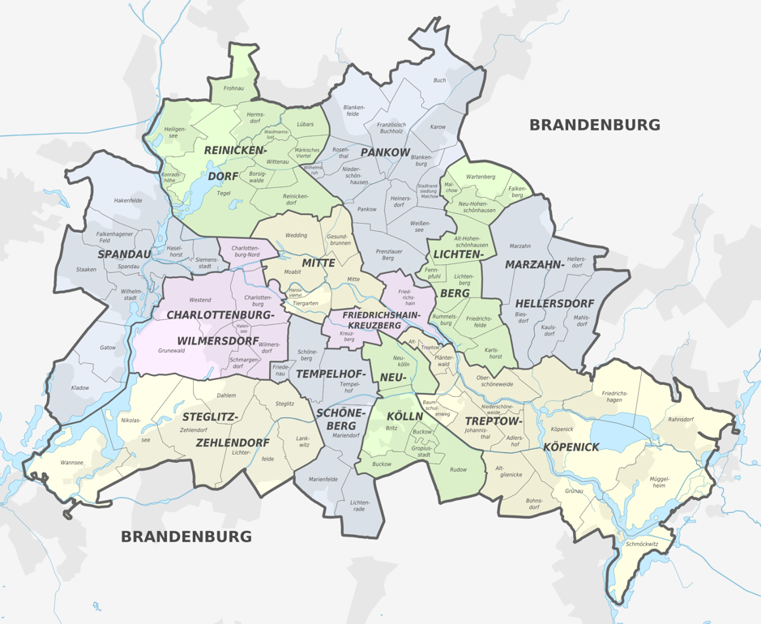

### **Data Source and Reasoning**

Based on definition of our problem, factors that will influence our decision are:

* number of existing restaurants in the neighbourhood (any type of restaurant)
* number of specialty vegan restaurants in the neighbourhood, if any
* distance of neighbourhood from city centre
* Demographics of neighbourhood

To work this, I will primary be sourcing location-based data through the Foursquare API as well as available wiki data. There are a few important data points we can use to attempt to answer the question above.

1) As mentioned above would like to establish frequency of types of restaurants (vegan and other) in the Berlin boroughs. This will allow calculation of restaurants per capita. Such data will be gathered through geospatial data (longitudinal and latitudinal coordinates) which can be used in the in foursquare database which can map places of note on maps including venues such as restaurants and cafes, museums and shops.

2) Another key point of interest for this research in the foursquare API data is restaurant reviews. By comparing the reviews and ratings of both vegan and other restaurants in the city we may be able to establish the degree of popularity of restaurants potentially giving us a idea of tastes the residents of Berlin.

3) Demographic data including population and ethnicity of the boroughs will allow us to compare and contrast restaurant data. This data will be sourced by web scrapping Wikipedia. It is also this table that will give us a definitive list of the berlin boroughs which can be used to search the centre coordinates of each boroughs.

### **Data Collection and Cleaning**

The main Python modules that will be used for data collection, cleaning and analysis include:

* Request
* BeautifulSoup
* Pandas
* Numpy
* Geocoder
* Folium
* the Foursquare API

They will be used for collecting and cleaning the data, reorganizing and transforming data including One-Hot-Encoding.

### **Results**

Neighbourhoods identified:

Clustered Neighbourhoods with higher frequency of restaurants:

Top 20 restaurant types across the city:

Neighbourhood with the most Vegetarian / Vegan restaurants:

## **Conclusion**

From the analysis we can establish that Vegetarian / Vegan Restaurant are not quite as popular by frequency in Berlin as we might thought. The top five most popular types of restaurants across the city were as follows:

1. Italian
2. German
3. Vietnamese
4. Greek
5. Falafel

Vegetarian / Vegan restaurants were 12th on the list of most frequent restaurants in the city. This might make you conclude that Berlin is less hipster than once thought. However, this could be analysed in future research where Berlin is compared with other German cites of similar size to see if it has comparably more or less Vegetarian / Vegan Restaurant.

The cluster analysis also found that the neighbourhood with the highest frequency of Vegetarian / Vegan restaurants was Neukölln, where it was actually the most frequent restaurant type. This was also the case in Tiergarten. The neighbourhoods with the highest frequency are below:

1. Neukölln
2. Tiergarten
3. Friedrichshain
4. Lichtenberg
5. Fennpfuhl

Neukölln, Tiergarten and Friedrichshain are all inner city neighbourhoods with a higher level of young people but also higher levels of non-ethnic German (<https://en.wikipedia.org/wiki/Demographics_of_Berlin>). We could conclude that if we look at these neighbourhoods that that are younger and hipster though a correlation of higher frequency of Vegetarian / Vegan restaurants. However, it is not conclusive as these neighbourhoods have higher levels of international residents which could be the reason for the higher frequency.

